Ealing Mainstream Universal Speech and Language Therapy Team
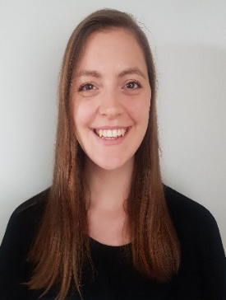
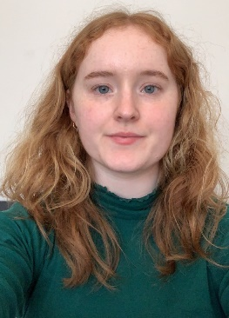


Lucy Flaherty
Ciara Howey
Emily Ball

What we do:
We provide a universal speech and language therapy service to families of children over 5 in Ealing. Children do not need a referral to access our service. We provide:
- Workshops for parents
- Training for practitioners
- Student workshops on Speech and Language Therapy as a career


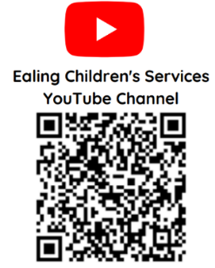
- Information and advice via our advice line service
Ealing Speech & Language Therapy Facebook
- Information, advice and videos via our social media

Did you know?
Relationships: Language and social communication are important to all children's development.
10% of children have long-term communication difficulties - that's 2-3 children in every classroom
Good spoken language skills are strong predictors of later academic success.

To contact our team:
Facebook: www.facebook.com/SLTEaling

Advice line: email on ealing.sltadvice@nhs.net.
We are open Tuesday – Friday 1-4pm

Address:
Speech and Language Therapy Team,
Mainstream Schools Universal Service,
Carmelita House, 21-22 The Mall, W5 2PJ

Tel: 0300 1234 544

Ealing Speech and Language Therapy Over 5’s Parent Workshops

During the Spring term 2024, we are running a range of FREE parent workshops. Your child does not need a referral to access this service.

Workshop: | Date/time | This is for | Location | How to Book
Understanding behaviours  and supporting emotions | Wednesday 28th February  1-2pm | Parents of children aged 5 and over | Online | Email wlm-tr.sltuniversalservices@nhs.net  with your name and the workshop name
Using visuals to support communication | Friday 8th March  11am-12pm | Parents of children aged 5 and over | Online
Social Stories  With Ealing Anchor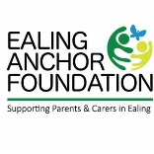 | Wednesday 7th February  10.30 – 12.00 | Any parent | Windmill Children’s Centre  UB6 9DZ | Complete the form:  https://forms.office.com/e/VN6zggPQmE

“I would love to attend more sessions in the future!”

“Very informative with lots of useful resources”

“All parents need this kind of workshop to help us feel better and brighter”


“Gave me strategies to try in the future”

Ealing Speech and Language Therapy
Over 5’s Parent Workshops
Are you a parent of a school-aged child looking for practical advice?
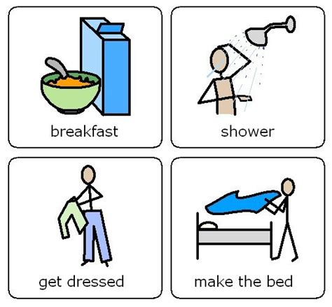


We are running a workshop on:
Using visuals to support communication
Friday 8th March
11-12pm
Online

On this workshop you will learn:
✔ The benefits of using visuals alongside spoken language
✔ How to introduce visuals
✔ How visuals can support routine and learning
✔ Where to find further support
PARENTS: to book a FREE place:
Email wlm-tr.sltuniversalservices@nhs.net with your name, the workshop title and the name of your child’s school

Ealing Speech and Language Therapy
Over 5’s Parent Workshops

Are you a parent of a primary school-aged child looking for practical advice?
We are running a workshop on:
Understanding behaviours and supporting emotions
Wednesday 28th February
1-2pm
Online



On this workshop you will learn:
✔ What are my child’s behaviours telling me?
✔ Practical ways to help children understand and express how they feel
PARENTS: to book a FREE place:
Email wlm-tr.sltuniversalservices@nhs.net with your name, the workshop title and the name of your child’s school

✔ Strategies to help manage emotions



