St Anselm’s Primary School
Year 1 | Autumn 1 |  | Autumn 2 |  | Spring 1 |  | Spring 2 |  | Summer 1 |  |  | Summer 2
Big Question linked to Whole School CST | How do we show care for others and God’s world? |  | Why do Christians wait for Jesus at Christmas? |  | How does Jesus teach us to love and care for others? |  | How does Jesus help us grow in love and kindness? |  | How do we show God’s love to people around us? |  |  | Why is it important to welcome others?
R.E. | Creation and Covenant  How does knowing that everything comes from God help us care for the world and talk to God through prayer?  That all that is comes from God.  Prayer is a way to draw closer to God |  | Prophecy and Promise  How does the Christmas story show God’s love and His promise to be with us?  The Christmas story reveals God’s love by  sending Jesus his Son. |  | Galilee to Jerusalem  How did Jesus meet people and change their lives by showing love and kindness?  Jesus encountered lots of people in His  life and changed their lives for the better. |  | Desert to Garden  What do the events of Holy Week teach us about Jesus’ love, sacrifice, and care for others?  The events of the last week of Jesus’ life. |  | To the Ends of the Earth  How does Jesus show God’s love for everyone?  The narrative sequence of the life of Jesus  Christ. |  |  | Dialogue and Encounter  How does belief in one God help people live together peacefully?  To understand the Christian belief in One God.  Jewish belief in One God
CST Links | Human Dignity  Every person is created by God and deserves love and respect.  Stewardship of Creation  The world is God’s gift, so we must look after it carefully.  The Common Good  Caring for the world helps everyone live well.  Responsibility  We are responsible for taking care of creation in our daily choices. |  | Human Dignity  Every person is loved by God and should be treated with kindness and respect.  God’s love helps us show love in our words and actions.  The Common Good  Caring for others helps everyone live happily together.  Solidarity  We are all part of God’s family and should support one another. |  | Human Dignity  Jesus treated every person with love and respect.  Love and Compassion  Jesus helped people who were sick, poor, or lonely.  The Common Good  Jesus’ actions helped people live better lives together.  Solidarity  Jesus showed that we should care for and support one another. |  | Human Dignity  Jesus’ life shows that every person is important and loved by God.  Joy and Hope  Celebrations remind Christians of God’s love and hope for everyone.  The Common Good  Celebrating together helps build a caring and happy community.  Solidarity  Christians come together to share faith, support, and love. |  | Human Dignity  The Holy Spirit helps us see that every person is important and should be respected.  The Common Good  Good choices help everyone live together happily and safely.  Solidarity  The Holy Spirit helps people support and care for each other.  Responsibility  We are helped to choose what is right and kind. |  |  | Human Dignity  Every person is created by God and deserves respect.  The Common Good  Peaceful living helps everyone in the community.  Respect for Others  We should listen to and value different beliefs.  Solidarity  We are all part of one human family and should care for each other.
CST  (Catholic Social Teaching) | Rooted In Love  Care for Creation |  | Rooted In Love  Option for the Poor |  | Rooted In Love  Solidarity and Peace |  | Rooted In Love  Community and Participation |  | Rooted In Love  Dignity of Workers |  |  | Rooted In Love  Dignity
Novel | 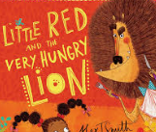 |  | 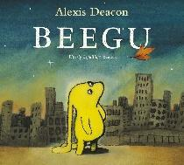 |  | 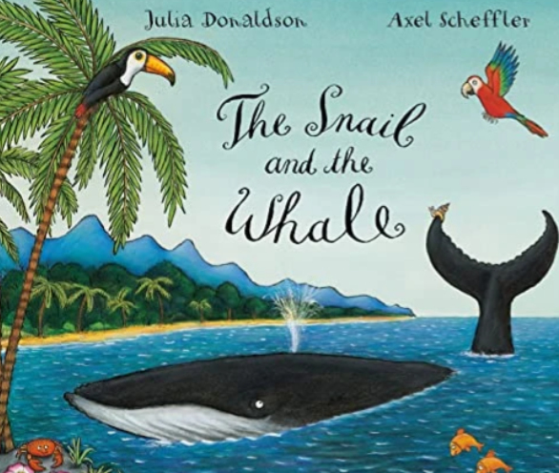 |  | 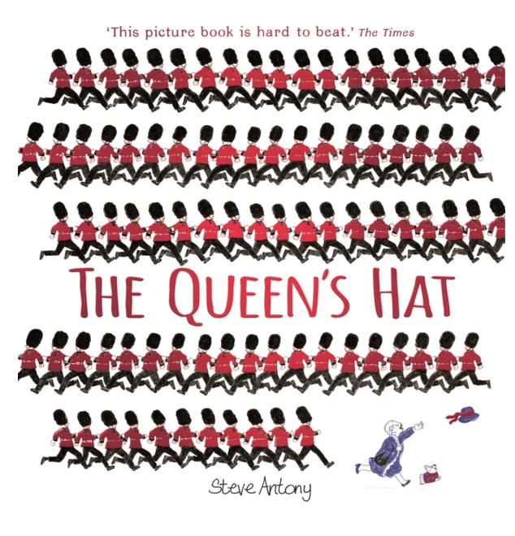 |  | 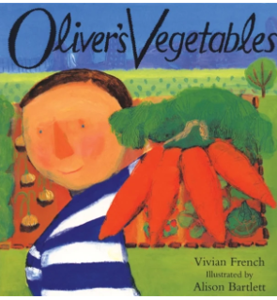 |  |  | 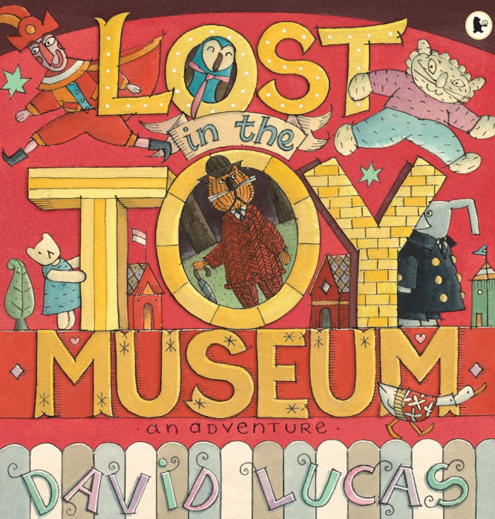
Novel | Dear Zoo  The little red and the very hungry lion.  Coming to England |  | Beegu  Town mouse and Country mouse |  | The snail and the whale  The Papaya that spoke |  | Queen’s Hat  Queen Elizabeth II |  | Oliver’s Vegetables  From Seed to Plant |  |  | Lost in the toy museum  Tin Toy
Focus Genres | Retelling a Narrative  Alternate endings  Instructions  Fact file |  | Retelling a narrative  Alternative ending  Diary  Character description |  | Narrative  Recount  Character Description  Riddle poem |  | Poster  Description  Narrative |  | Creating Description  Recounts  Fact Files |  |  | Writing letters  Instructions  Writing about real life events
Maths | Place Value within 10 (5w)  Addition and Subtraction (2w) |  | Addition and Subtraction (3w)  Shape (1w)  Assessment week (1w)  Consolidation (1w) |  | Place Value within 20 (3w)  Addition and Subtraction within 20 (3w) |  | Place Value within 50 (2w)  Length and Height (2w)  Mass and volume (2w) |  | Multiplication and Division (3w)  Fractions (2w)  Position and Direction (1w) |  |  | Place Value within 100 (2w)  Money (1w)  Time (2w)  Assessment week (1w)
Science  Stewardship of Creation  The seasons, plants, animals, and materials are all part of God’s world, which we must care for.  Wonder and Awe  Learning about nature helps us see how amazing God’s creation is.  Human Dignity  All people are part of creation and deserve care and respect.  Responsibility  We can make good choices to look after the environment and living things. | Seasonal Changes  How do the seasons show us God’s creation and help us care for the world around us?  What are the four seasons?  What are seasons and why do we have them?  Why are there so many leaves on the ground in Autumn?  Why is it so cold in Winter?  Why do most people love the Spring?  Why don’t we need to wear so many clothes in Summer? |  |  | Everyday Materials – Properties of materials  How can learning about materials help us care for God’s world and use things wisely?  What is the difference between an object and a material?  How can we sort different objects?  Where do materials come from?  How are materials different?  How can we sort materials according to their properties? |  |  | Plants  How does learning about plants help us understand God’s creation and how to care for living things?  What are the parts of a plant?  What do you think will happen to the seeds if we put them in a pot full of soil?  How can we identify trees?  What plants grow in our local area?  How are seeds different? |  |  | Animals Including Humans  How does learning about animals and humans help us care for living things?  Which parts of the human body are responsible for our senses?  What can our different senses do?  Which animals are herbivores, carnivores and omnivores?  Do all animals have the same senses as humans?
History  Human Dignity  All people in the past and present are important and deserve respect.  The Common Good  Changes in transport and toys have helped make life better for many people.  Learning about Queen Elizabeth II and history helps us value people’s lives and contributions.  Solidarity  People in the past and present are connected through shared human experience. |  |  | How did going to the Moon show the importance of working together for the common good?  Why did people risk their lives to go to the Moon?  How did the space race between America and the Soviet Union lead to the Moon landing in 1969?  What did the astronauts do on the Moon, and how do different accounts tell the story?  Should space travel continue?  How do we remember and celebrate important people? |  |  |  | Queen Elizabeth II  How did Queen Elizabeth II help and care for people?  What is a monarch?  Who was Queen Elizabeth II?  What was her life like?  What is the role of the queen called Elizabeth II?  Where does the Queen live?  Why is Queen Elizabeth famous? |  |  |  |  | How have changes to our High Street since the 1950s helped our community?  What was the high street like before?  How has the high street changed?  What was in the shops before?  What was it like to shop for food?  How was my food packaged/stored?  How could I pay for my purchases?
Geography  Human Dignity Everyone in our local area matters and deserves respect  Stewardship of Creation  We look after our local area as part of God’s world.  The Common Good  Caring for our school and community helps everyone.  Responsibility  We can help keep our environment clean and safe. | Our Wonderful World  How does learning about our local area help us care for where we live?  Where in the world is the UK?  Where do you live? What are the human and physical features of our school? Where is our school and key school landmarks located?  How do you use a map?  What is our local area like?  How do you travel to school?  Where is our school located and how can we find it on a map? |  |  |  | Bright Lights, Big City  How does learning about the UK help us respect places and people?  What is the United Kingdom?  What is a city?  What are the capital cities of the UK?  What is special about England?  What are the four nations of the United Kingdom of Great Britain?  Why the UK is called the United Kingdom?  What is the difference between a sea and an ocean? |  |  |  | Journey around the World  How does learning about the world help us care for God’s creation?  What are continents and where are they? What is the equator, north pole and south pole and what is the weather like there? What is the weather like in the UK and when does the weather change? What are seas and oceans and what are the names of some of the biggest ones?
Art  Human Dignity  Portraits and people in art remind us that every person is special and valuable.  Stewardship of Creation  Natural art helps us notice and care for God’s world.  Our talents and imagination are gifts from God that we can use to help and inspire others.  The Common Good  Art can bring joy, beauty, and meaning to communities.  Solidarity  Learning about artists from different cultures helps us value different traditions and ideas. | Andrew Goldsworthy  How can natural art help us care for God’s world?  Why is he important as an artist?  What materials can you see? What colours, shapes and patterns can you see?  Can you make a natural sculpture like Andy Goldsworthy? |  |  |  | Mondrian  How does abstract art help us show creativity and beauty?  Why is he important as an artist?  What images do you see? What colours, shapes and patterns can you see? Can you make an abstract picture like Piet Mondrian? |  |  |  | Portraits of the Queen  (Painting, drawing, colour) How can portrait art help us value people, show respect, and recognise the dignity of every person?  Why is she important as an artist?  How does she work as a portrait artist? What medium does she use? What skills does she use? What is observational drawing? Why is it realistic? How does she use colour?
DT  Human Dignity  We design things for real people, showing that everyone matters.  The Common Good  Our products (smoothies, puppets, cards) can bring joy, health, and happiness to others.  Stewardship of Creation  We should use food and materials carefully and avoid waste.  Solidarity  We think about how our designs can help or include other people.  Responsibility  We make safe, thoughtful choices when designing and creating |  |  | Smoothie  How can making smoothies help us stay healthy and care for others?  Where can you buy fruit and vegetables locally?  What fruits are for sale near to where you live?  What equipment do you need to create our smoothie?  What do you think of your smoothie?  What information is on a smoothie container? |  |  |  | Celebration Card  (Sliders and Levers)  How can making celebration cards help us show love, joy, and care for other people?  What is the celebration you are designing?  What colours will you use?  What pictures and images will you use?  What greeting will be on the card?  What kind of mechanism will you use? |  |  |  |  | Puppets  How can making puppets help us care for and think about others?  What do you use a puppet for?  What is the character of the puppet?  What type of materials have been used?  How has any decoration been added?  Who has this puppet been made for?
Computing (Purple Mash)  Human Dignity  Everyone should be treated kindly and respectfully online and offline.  Responsibility  We must use devices safely and follow rules when using technology.  The Common Good  Technology can help people learn, share, and work together.  Solidarity  We use technology to connect and support others.  Truth and Care  We should only share kind, safe, and true information. | Unit 1.1 Online Safety & Exploring Purple Mash  Login safely How to find saved work Start to add pictures and text How to open, save and print Understand the importance of logging out.  What is a password and why should we keep them safe?  Where is my work stored?  Unit 1.2 Grouping & Sorting  Sort items using a range of criteria.  In what ways can we sort objects? |  | Unit 1.3 Pictograms  Use a pictogram to record the results of an experiment.  What does our data show?  Unit 1.4 Lego Builders  To follow and create simple instructions on the computer.  To consider how the order of instructions affects the result To use the direction keys.  What is an instruction?  Why do we need to debug code? |  | Unit 1.5  Maze Explorers  To follow and create simple instructions on the computer.  To consider how the order of instructions affects the result To use the direction keys.  What is an instruction?  Why do we need to debug code?  Unit 1.6  Animated Story Books  Add animation to a story  Add sound to a story  Add backgrounds  What is an animated story? How can I use the computer to make my story more interesting? |  | Unit 1.7  Coding  Use code to make a computer program Understand what an object and actions are Understand what an event is Use an event to control an object.  What is coding?  Why is it useful to design before coding? |  | Unit 1.8  Spreadsheets  Enter data into spreadsheet cells Use the count and speak tools.  Why does a spreadsheet look like? How could you use the count and speak tools? |  |  | Unit 1.9 Technology Outside School  Find examples where technology is used.  What is technology?  How does technology make our lives easier?
Music  (Charanga)  Human Dignity  Everyone’s voice and music matter.  The Common Good  Music helps people feel happy and connected.  Solidarity  Singing and playing together helps us care for one another.  Music can make people feel calm, joyful, and included. | Unit 1  Hey You!  Gene: Hip Hop  Skill: Listening and appraising |  | Unit 2  Rhythm In the Way  We Walk and Banana Rap  Genre: Action Songs/Reggae  Skill: Singing and Performing |  | Unit 3  In the Groove  Genre: Various  Skill: Listening and appraising (comparing genres) |  | Unit 4  Round and Round  Genre: Latin  Skill: Building on skills-playing musical instruments. |  | Unit 5  Your imagination  Genre: Pop  Skill: Composing |  |  | Unit 6  Reflect, Rewind and Replay  Genre: Various  Skill: Consolidating learnt skills and revising songs? Musical activities
P.E | Football |  | NFL/rugby |  | Tennis |  | Athletics/Dance |  | Mixed Tactics Game |  |  | Gymnastics
RSHE/PSHE  Life to the Full  Human Dignity  Every person is special, unique, and loved by God.  We should treat ourselves and others with kindness and care.  The Common Good  Good choices help create happy and safe communities.  Solidarity  We are all part of God’s family and should support one another.  We learn how to make safe, kind, and healthy choices. | Module 1 Created and Loved by God |  |  |  | Module 2 Created to Love Others |  |  |  | Module 3 Created to Live in Community
 | Unit 1  Religious understanding  Let the Children Come | Unit 2  Me, My Body, My Health  I Am Unique  Girls and Boys  Clean and Healthy (My Body) | Unit 3  Emotional Well- Being  Feelings, Likes and Dislikes  Feeling Inside Out  Super Susie Gets Angry | Unit 4  Life Cycles  The Cycle of Life  Beginnings and Endings  Change is All around | Unit 1  Religious Understanding  God Loves You | Unit 2  Personal relationships  Special People  Treat Others Well…  ..and Say Sorry | Unit 3  Life Online  Real-Life Online  Rules To Help Us | Unit 4  Keeping Safe  Good and Bad Secrets  Physical Contact  Harmful Substances  Can You Help Me? (Part 1)  Can You Help Me?  (Part 2) | Unit 1  Religious understanding  Three In One  Who is My Neighbour? |  | Unit 2  Living in the wider world  The Communities  We Live In  Who Will I Be?  Needs and wants
Enrichment | Local visit Southall Broadway - Geography  Seasonal Walk  Pantomime  Cultural Day (Diwali)  Black History Month  World Mental Health Day  Anti-Bully Week/Odd Socks Day  Internet Safety  Speak Out & Staff Safe- NSPCC  Road Safety Week  World Kindness Day  Library Visits  Scholastic Book Fair  Christmas decoration-Plastic Pollution  After School Clubs: Multi-Sports, Girls Football, Boys Football. |  |  |  | Science Museum  Story tellers- Rainbow Theatre  National Storytelling Week  Safer Internet Day  World Book Day  British Science Week  Mother’s Day  World Poetry Day  World Book Day  Library Visits  Science Week  Plastic Pollution Count  Mental Health Week  After School Clubs: Multi-Sports, Girls Football, Boys Football. |  |  |  | Buckingham Palace visit  Walk to School Week  Laudato Si Day (Earth Day)  Whole School Live Farm Visit  Sports Day  Library Visits  Theatre Visits KS2  After School Clubs: Multi-Sports, Girls Football, Boys Football.
Religious Events | Whole School Mass  Stay & Pray- Year 1  CAFOD National Assembly for Primary School  Feast Day Assemblies  Gospel Assemblies  Education Sunday  Year 6 Whole School Liturgy- St Francis of Assisi  St Vincent de Paul  Archangels Feast Day  Saint Therese of the Child Jesus  Year 5- Harvest Assembly  CAFOD Harvest Fast Day  Ealing Deanery Mass  Our Lady of the Rosary  Diwali Celebrations  All Saints Holy Day of Obligation  Guru Nanak Birthday  UN Climate Change Conference (COP 30)  Remembrance Day- Memorial  CAFOD Jubilee Celebration  Advent Liturgy- Father Peter  Advent Liturgies  EYFS Nativity  KS1 Nativity  Reconciliation KS2  Carol Service for Parents  Elderly Care Home Carol Concert  Children in Need Appeal |  |  |  | Feast of the Epiphany Mass  Stay & Pray- Year1  Year 1 Assembly  Presentation of the Lord  Mardi Gras celebration and parade  Family Fast Day  Lent Liturgies- KS2  Palm Sunday  Holy Thursday-Last Supper  Good Friday- Crucifixion  Resurrection  Reconciliation KS2  Stations of the Cross  Mother’s Day  Catholic Children Society Lenten Appeal |  |  |  | St Anselm’s Feast Day- Mass  Stay & Pray- Year 1  Laudato-Si Day  Rosary- Legion of Mary  Rosary-Month of Mary  Our Lady of Mary Procession  St Joseph the Worker  Father’s Day  Visits to other Faith’s  SS Peter & Paul Mass  Year 6 Leaver’s Mass

