St Anselm’s Primary School
Year 5 | Autumn 1 |  | Autumn 2 |  | Spring 1 |  | Spring 2 |  | Summer 1 | Summer 2
Big Question linked to Whole School CST | How can Catholic Social Teaching help us respond to injustice in the world? |  | How does Christian hope inspire people to bring change in the world? |  | How do Jesus’ teachings inspire Christians to act justly and love others in the world today? |  | How does new life in Christ inspire Christians to bring love and kindness to the world? |  | How does sharing God’s love challenge Christians to help people across the world? | How does welcoming others challenge Christians to build a more inclusive world?
R.E. | Creation and Covenant  How does knowing that we are made in God’s image help us understand our worth and our responsibility to care for others and the world?  The Moses story, focusing on the two key  events of the call and the covenant. |  | Prophecy and Promise  How does God’s call to love others help us live in a fair, kind, and caring way?  There were great kings anointed and chosen  in the Old Testament. For Christians, Jesus  fulfils the promises made to David. |  | Galilee to Jerusalem  How does the life and teachings of Jesus help us understand how to love, forgive, and care for others?  The Beatitudes from the Sermon on the  Mount. The great commandment and  parable about living out God’s law. |  | Desert to Garden  How does the Church celebrate the life, death, and resurrection of Jesus, and how does this help us live with hope and love for others?  Ash Wednesday marks the beginning of  the season of Lent. Sacrament of  Reconciliation. Sorrowful mysteries of the |  | To the Ends of the Earth  How does the Holy Spirit guide Christians to live, make good choices, and care for others?  The actions, signs, prayers, and symbols of the  Catholic rite of Confirmation. The narrative  of Pentecost and gifts of the Holy Spirit. | Dialogue and Encounter  How can people of different faiths live together with respect, understanding, and peace?  The Old Testament and God’s covenant with  Abraham is the foundation.
CST Links | Human Dignity  Every person is made in the image of God and has equal value.  Stewardship of Creation  We are responsible for caring for ourselves, others, and the world God created.  The Common Good  When we respect ourselves and others, we help build a fair and caring society.  We are called to treat others with kindness, respect, and fairness. |  | Human Dignity  Every person is loved by God and deserves respect.  The Common Good  Loving others helps build a fair and caring community.  Solidarity  We are all connected and should care for one another.  Peace  God calls us to treat others fairly and work for peace. |  | Human Dignity  Jesus shows that every person is important and loved by God.  Love and Compassion  Jesus teaches us to love others, especially those in need.  Peace  Jesus shows us how to forgive and live peacefully with others.  The Common Good  Following Jesus helps build a kinder and fairer community. |  | Human Dignity  Jesus’ Resurrection shows that every person is loved by God and has hope.  Peace  The Church celebrates that God brings new life and hope to everyone.  The Common Good  Church celebrations bring people together as a caring community.  Solidarity  Christians support and care for one another, especially in difficult times. |  | Human Dignity  The Holy Spirit helps people recognise the value of every person.  The Common Good  Guided by the Holy Spirit, Christians try to make choices that help everyone.  Solidarity  The Holy Spirit inspires people to support, encourage, and care for others.  Justice and Peace  Christians are called to act fairly and work for peace in the world. | Human Dignity  Every person is created by God and deserves respect, no matter their faith.  The Common Good  Living peacefully together helps build a better society for everyone.  Solidarity  We are all part of one human family and should care for each other.  Respect and Dialogue  Understanding different beliefs helps reduce conflict and build friendship.
CST  (Catholic Social Teaching) | Rooted In Love  Care for Creation |  | Rooted In Love  Option for the Poor |  | Rooted In Love  Solidarity and Peace |  | Rooted In Love  Community and Participation |  | Rooted In Love  Dignity of Workers | Rooted In Love  Dignity
Novel | 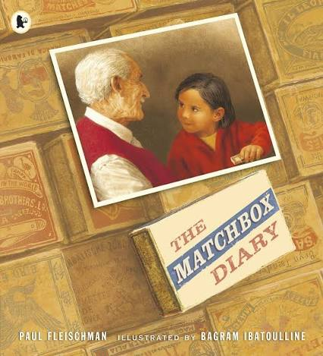  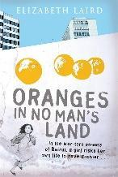 |  | 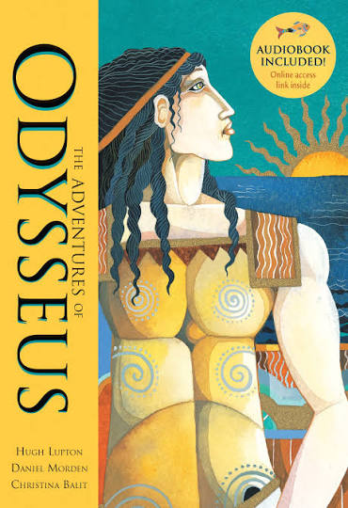 |  | 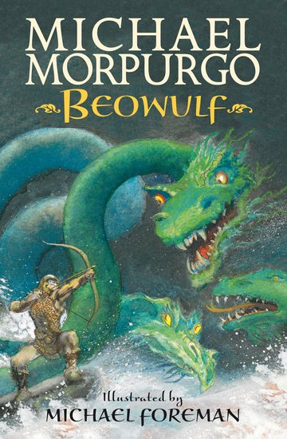  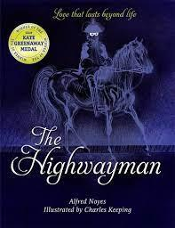 |  | 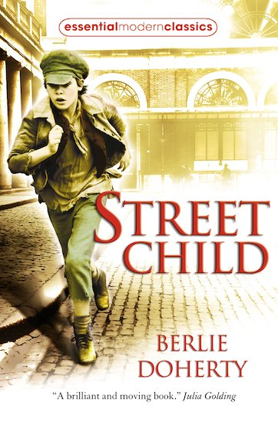 |  | 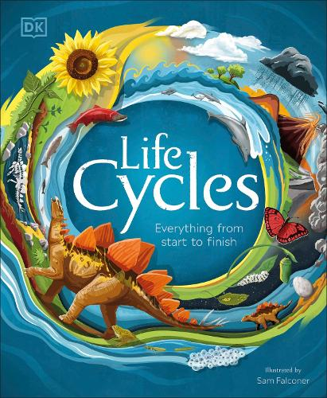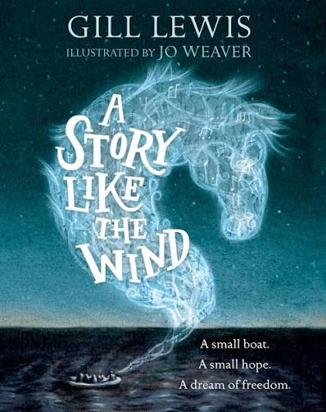 | 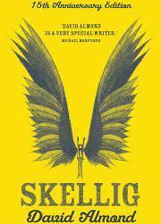
 | Oranges in no man’s land by Elizabeth Laird  The Matchbox Diary By Paul Fleischman |  | Odysseus by Hugh Lupton |  | The Highwayman by Alfred Noyes  Beowulf by Michael Morpurgo |  | Street Child by Berlie Doherty |  | A story like the wind by Gill Lewis  Lifecycles by Sam Falconer | Skellig by David Almond
Focus Genre | Narrative recount – Oranges in no man’s land  Setting description writing  Informal letter writing |  | Myth writing  Letter writing  Character description |  | Newspaper report for Highway man and description on what to look out for  Write a diary recount before Beowulf faces Grendel |  | Advertisement  Playscript |  | Narrative writing  Lifecycles | Diary entry exploring Mina’s feelings.  Character description (Skellig)  Description using figurative language (setting)
Maths | Place Value (3w)  Addition and Subtraction (2w)  Multiplication and Division A (1w) |  | Multiplication and Division (2w)  Fractions (3w)  Assessment Week (1w) |  | Multiplication and Division B (3w)  Fractions B (2w)  Decimals and Percentages (1w) |  | Decimals and Percentages(1w)  Perimeter and Area (2w)  Statistics (2w)  Assessment week (1w) |  | Shape (3w)  Position and Direction (2w)  Decimals (1w) | Decimals (2w)  Negative numbers (1w)  Converting Units (2w)  Volume (1w)  Assessment week (1w)
Science  Human Dignity  Understanding human growth and development helps us value every stage of life  Stewardship of Creation  The solar system, materials, plants, and animals are part of God’s creation, which we must care for.  The Common Good  Science helps us understand the world so we can improve life for everyone. | Earth and Space  How does learning about space help us understand God’s world?  What is the solar system?  Can you name the 8 planets?  How do planets move in space?  Do you think that we have always known that the planets move around the sun?  Why do we have night and day?  How can shadows show that the Earth is rotating?  Why do they think the moon is in orbit around the Earth? |  | Forces and Mechanisms  How can learning about forces help us use science to help others and care for the world?  What forces are acting on an object?  Who was Isaac Newton and why is he significant?  What is the difference between weight and mass?  What is air resistance?  What is water resistance?  How does this mechanism work using force? |  | Properties and Changes of Materials  How does learning about materials and their changes help us use resources wisely and care for God’s creation?  What are the properties of solids, liquids and gases?  What state of matter are your materials?  How can we group and compare materials?  How can we separate materials?  What is a solution?  Do all liquids freeze?  What are filtering, sieving and evaporation?  What happens to solids when they are heated? |  | Reproduction and life cycles: plants  How does learning about how plants reproduce and grow help us understand God’s creation and our responsibility to care for the natural world?  How do plants reproduce?  How do we reproduce plants through cuttings?  What do the different parts of the flower do?  What is the lifecycle of a plant?  What is the process of reproducing through cuttings? |  | Reproduction and life cycles: animals  How does learning about life cycles help us respect and care for living things?  How do different animal embryos change?  Is there a relationship between a mammal’s size and its gestation period?  What do you think are the differences between the life cycle of a human and other mammals? | Human development  How does learning about how we grow help us care for ourselves and others?  What can a toddler do that a baby can’t? What new skills do we learn as children?  Why do we go through puberty?  What new skills can we learn as adults?  What happens to our hair and skin as we age?
History  Human Dignity  All people and civilisations, past and present, have value and deserve respect.  Justice  Studying Benin helps us think about fairness, power, and how people should not be treated unfairly or have their culture taken without respect.  Solidarity  Ancient Greece and Benin show that all humans have shared experiences, ideas, and achievements across cultures.  The Common Good  Greek ideas (democracy, philosophy) and Benin’s achievements (art, organisation) helped shape societies and continue to influence the world.  Respect for Diversity  Different civilisations show different beliefs, governments, and ways of life that should be valued. |  |  | Ancient Greece  How did Ancient Greece influence ideas about fairness and society today?  What are the main features of Ancient Greek society?  How did the city-states in Greece differ?  How was Athens ruled?  Who were Greek philosophers?  What do Greek myths tell us?  How have the Greeks influenced our lives today? |  |  |  | Victorians - Was the Industrial revolution good for everyone?  What do we mean by the Industrial Revolution?  Who had an answer to the problem?  How did travel and transport change during the Industrial Revolution? |  |  | Benin Civilisation  How can learning about the Benin Civilisation help us understand respect for different cultures and the importance of fairness and justice between societies?  What are the Benin Bronzes found in the British museum?  What was Benin city like 1000 years ago?  What was the role of the Oba in Benin society?  What type of religion did they follow in Benin?  How did Europe raid and change Benin?  What differences were there between Benin and Europe?
  Who worked in the mills and the mines?
  Where did the cotton for the mills come from?
  Was the Industrial Revolution good for everyone?
Geography  Human Dignity  People in every country (UK, Spain, Costa Brava, etc.) deserve respect and fair living conditions.  Stewardship of Creation  The Earth has different climate zones and landscapes that we must respect and protect.  The Common Good  Transport, trade, and maps help people connect and improve life for everyone.  Solidarity  All people are connected, even if they live in different parts of the world.  Justice  Resources and environments should be used fairly so all communities can thrive. | Investigating our World  How does learning about maps and climate zones help us understand God’s world and our responsibility to care for people and the environment?  Why does a place’s location in the world affect its climate?  What is a climate zone?  How is the climate in the UK different from that in the tropics?  How does the climate vary around the world?  What is special about each climate zone? |  |  |  | Studying a region in a European country.  Costa Brava in Spain.  How does learning about places like Costa Brava help us respect others and the world?  Where in the world is Europe and what is it like?  Where in Europe is Spain and what is it like?  Is the land of Costa Brava the same as ours?  Is the climate and biome of Costa Brava the same as ours?  Is the economy of Costa Brava the same as ours?  Is the Costa Brava a world away from our local area? |  |  |  | The Silk road  Was the silk road successful in increasing trade across the East?  What were the cities of the early Islamic civilisation?  Why was the city of Baghdad round?  What trade happened along the Silk Road?
  What are the physical and human features of the Silk Road?
  What biomes are found along the Silk Road?
  Was the Silk Road successful in increasing trade across the East?
French | Bon appetit  (Healthy Eating) |  | Je suis le musician  (I am the music man) |  | En route pour l’ecole  (On the way to school) |  | Scene de plage  (Beach scene) |  | Le retour du printemps  (The return of spring) | Les planets  (The planets)
Art  Human Dignity  Every artist and culture shows the value of human creativity and expression.  The Common Good  Art helps people share ideas, stories, and beauty with others.  Solidarity  Studying artists from different times and places connects us to people around the world.  Respect for Diversity  Different art styles (Hockney, Matisse, Greek ceramics) show different cultures and ways of seeing the world. | Hockney  Landscape study  Colour (shade),  Shape, perspective  How does studying Hockney’s landscapes help us appreciate God’s creation and use our creativity to share beauty with others?  Who is Hockney?  Why is he important as an artist?  What materials can you see?  What colours, shapes, lines and patterns can you see?  What is important in landscape composition?  What is perspective?  How do we draw perspective? |  |  |  | Greek ceramics  Greek art and pattern design shape and form  How does studying Greek ceramics help us value different cultures, respect human creativity, and use art to share stories and meaning?  What style of art was used to decorate Greek ceramics?  Why is Greek Pottery considered a significant form of art today? What contribution do these Greek ceramic artefacts and their visual imagery make to the history of art?  What is unique about their type of art?  What colours, techniques, styles, shapes and patterns can you see? What scenes, animals, figures and animals have they depicted and what are the key elements that typify the style of the artwork? |  |  |  | Matisse  Abstract flowers and leaves, colours, shapes, patterns, printing  How does studying Matisse’s art help us use creativity to express ideas, appreciate beauty, and value the gifts God has given us?  Who was Henri Matisse and why was he important as an artist? What contribution do they make in the history of art?  What is unique about their type of art?  What techniques and mediums can you see? What animals, figures, colours, shapes and patterns can you see? Can you make a collage cut out composition?
DT  Human Dignity  Good design helps meet people’s needs and improves wellbeing.  The Common Good  Products like food, clothing, and fairground rides can improve life for individuals and communities.  Stewardship of Creation  We should use food, fabrics, and materials responsibly and avoid waste.  Responsibility  Designers must think carefully about safety, health, and who the product is for. |  |  | Fairground Rides  How can designing fairground rides help us think about safety, enjoyment, and creating experiences that bring happiness to others?  What do you do at a fairground?  How will your ride be themed?  What will make your ride original and authentic?  What is a Task Board? |  |  |  | Eatwell Pizza  How can making pizza help us think about healthy eating and caring for others?  What do we eat when we eat at home or when we eat out?  Where do we get our Pizza?  What is Market Research?  What makes a good pizza?  What are the key messages from the Eatwell Guide? How can our pizza promote the Eatwell Guide?  What is a task board?  What is an entrepreneur? |  |  | Waistcoats  How can designing and making clothing help us care for others by meeting their needs and using materials responsibly?  How do you measure Up?  What stitch did you pick and why?  What is a Mood Board?  Who is the product for?  How is your design like your final product?
Computing  (Purple Mash)  Human Dignity  Everyone deserves to be safe, respected, and treated kindly online and offline.  The Common Good  Technology can be used to help people learn, communicate, and solve problems together.  Responsibility  We must use computers, data, and the internet safely and wisely.  Truth and Justice  We should share accurate information and think carefully about what we see online.  Solidarity  Technology connects people, so we should use it to support and include others. | Unit 5.1  Coding  Begin to simplify code Create a playable game Begin to understand what a function is and how they work Understand different variable types and how they are used differently.  Describe how you would use variables to make (e.g. a timer countdown and a score pad for a game) |  | Unit 5.2  Online Safety  Review sources of support when using technology and what responsible behaviour looks like Know appropriate and inappropriate text, photos and videos and the impact of sharing them online.  Who do I tell if I see anything online that makes me upset or scared? |  | Unit 5.3  Spreadsheets  Use formulae within a spreadsheet for conversions and to calculate area and perimeter of shapes Use a spreadsheet to model a real-life problem.  How would you add a formula so that (e.g. the cell shows the product of 2 other cells) Explain what a spreadsheet model of a real-life situation is and what is could be used for. |  | Unit 5.4  Databases  Search for information in a database Contribute to a class database Create a database around a chosen topic  Why is the collaborative feature important? In what ways can I sort information in a database? |  | Unit 5.5  Game Creator  Plan a game Design and create the game environment to self and peer evaluate.  What makes a good computer game? Why is it important to continually evaluate your game?  Unit 5.6  3D Modelling  Begin to use the skills of computer aided design Explore the effect of moving points when designing Design, a 3D model to fit certain criteria.  How is CAD software used in industry? How can the objects designed in 2Design and Make be turned into 3D objects | Unit 5.7  Concept Maps  Know the uses of a concept map Create a concept map.  What is a concept map? How does a concept map help share ideas?
Music  (Charanga)  Human Dignity  Every person’s voice and creativity are valuable.  The Common Good  Music brings joy and unity to communities.  Solidarity  Singing and performing together helps people feel connected.  Musical skills are gifts that can be shared to help and inspire others.  Peace  Music can lift moods, comfort people, and create harmony. | Unit 1  Livin’ On A Prayer  Genre: Classic Rock  Skill: Appraise, sing and perform |  | Unit 2  Classroom Jazz (Stage 1)  Genre: Jazz  Skill: Listen, Appraise and Play |  | Unit 3  Make You Feel My Love  Genre: Pop Ballard  Skill: Sing and Improvise |  | Unit 4  The Fresh Prince of Bel-Air  Genre: Hip Hop  Skill: Improvise and Compose |  | Unit 5  Dancing in The Street  Genre: Motown  Skill: Singing and Playing | Unit 6  Reflect, Rewind And Replay  Genre: Various  Skill: Consolidate, compose and perform
P.E. | Football |  | NFL/rugby |  | Gymnastics |  | Athletics/Dance |  | Cricket | Badminton
RSHE/PSHE  Life to the Full  Human Dignity  Every person is valuable and deserves respect in all relationships.  The Common Good  Positive relationships help create safe and supportive communities.  Solidarity  We are all connected and should support and care for one another.  We are responsible for our actions, especially online and in friendships.  We should treat others with kindness, empathy, and understanding. | Module 1 Created and Loved by God |  |  |  | Module 2 Created to Love Others |  |  |  | Module 3 Created to Live in Community
 | Unit 1  Religious understanding  Calming the Storm | Unit 2  Me, My Body, My Health  Gifts and Talents  Girls’ Bodies  Boys’ Bodies  Spots and Sleep | Unit 3  Emotional Well- Being  Body Image  Peculiar Feelings  Emotional Changes  Seeing Stuff Online | Unit 4  Life Cycles  Making Babies (Part 1)  Making Babies (Part 2)  Menstruation  Hope Beyond Death  Coping with Change | Unit 1  Religious Understanding  God is Calling You | Unit 2  Personal relationships  Under Pressure  Do You want A Piece of Cake?  Self-Talk  Build Others Up | Unit 3  Life Online  Sharing Isn’t Always Caring  Cyberbullying | Unit 4  Keeping Safe  Types of Abuse  Impacted Lifestyles  Making Good Choices  Giving Assistance | Unit 1  Religious understanding  The Holy Trinity  Catholic Social Teaching | Unit 2  Living in the wider world  Reaching Out  The World of Work  Money and Me
Enrichment | Journey to Bethlehem- Gumley House Convent School  Fire Brigade  Solar System Workshop  Cultural Day (Diwali)  Black History Month  World Mental Health Day  Anti-Bully Week/Odd Socks Day  Internet Safety  Speak Out & Staff Safe- NSPCC  Road Safety Week  World Kindness Day  Library Visits  Scholastic Book Fair  Christmas decoration-Plastic Pollution  After School Clubs: Multi-Sports, Girls Football, Boys Football. |  |  |  | National Storytelling Week  Safer Internet Day  World Book Day  British Science Week  World Poetry Day  World Book Day  Library Visits  Science Week  Plastic Pollution Count  Mental Health Week  After School Clubs: Multi-Sports, Girls Football, Boys Football. |  |  |  | Joy of Movement- Brentford Community Scheme.  Walk to School Week  Laudato Si Day (Earth Day)  Whole School Live Farm Visit  Sports Day  Library Visits  Theatre Visits KS2  After School Clubs: Multi-Sports, Girls Football, Boys Football.
Religious Events | Whole School Mass  Stay & Pray- Year 5  CAFOD National Assembly for Primary School  Feast Day Assemblies  Gospel Assemblies  Education Sunday  Year 6 Whole School Liturgy- St Francis of Assisi  St Vincent de Paul  Archangels Feast Day  Saint Therese of the Child Jesus  Year 5- Class Assembly  Year 4 Liturgy  Year 3 Liturgy- Harvest Assembly  CAFOD Harvest Fast Day  Ealing Deanery Mass  Our Lady of the Rosary  Diwali Celebrations  All Saints Holy Day of Obligation  Guru Nanak Birthday  UN Climate Change Conference (COP 30)  Remembrance Day- Memorial  CAFOD Jubilee Celebration  Advent Liturgy- Father Peter  Advent Liturgies  EYFS Nativity  KS1 Nativity  Reconciliation KS2  Carol Service for Parents  Children in Need Appeal |  |  |  | Feast of the Epiphany Mass  Stay & Pray- Year 5  Presentation of the Lord  Mardi Gras celebration and parade  Family Fast Day  Lent Liturgies- KS2  Palm Sunday  Holy Thursday-Last Supper  Good Friday- Crucifixion  Resurrection  Reconciliation KS2  Stations of the Cross  Mother’s Day  Catholic Children Society Lenten Appeal |  |  |  | St Anselm’s Feast Day- Mass  Stay & Pray- Year 5  Laudato-Si Day  Rosary- Legion of Mary  Rosary-Month of Mary  Our Lady of Mary Procession  St Joseph the Worker  Father’s Day  Visits to other Faith’s  SS Peter & Paul Mass  Year 6 Leaver’s Mass

