Key Oral Health Messages:

Brush for 2 minutes, twice daily night-time most important

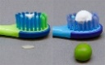
Use a fluoride toothpaste containing: 1000ppm for under 3 years old, just smear and over 3 years old 1450ppm a pea size

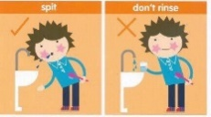
Spit out the toothpaste, do not rinse!

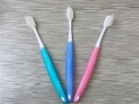
Change your toothbrush every 3 months or if someone in the household has a cold or viruses

Visit the dentist every 6 months


Keep sugar intake low try and avoid juice and fizzy drinks
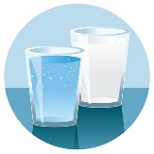
Milk in a cup and water is best

Oral health web page (scan below):


