20th November 2024
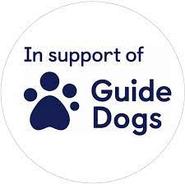
Dear Parents,

GUIDE DOGS FOR THE BLIND ASSOCIATION

We are excited to announce that our 'Truth to Power' school representatives in Years 5 and 6 have organized the Blindfold Challenge Fund Race to raise awareness and support the work of The Guide Dogs for the Blind Association.

We are hoping to arrange an Assembly with a member of the Guide Dogs for the Blind Association who will come and talk to the children about the importance of their work with the sight impaired community and bring one of their guide dogs into school for the children to meet.

We invite all pupils to participate in this fundraiser by completing the attached sponsor form or by making a donation directly.

The event will take place during P.E. lessons in the week beginning December 4, 2024. Please ensure that all donations and sponsor forms are returned to the school office by Friday 11th December 2024.

Thanking you in advance for your participation and generosity as always - in supporting this important cause!

Yours sincerely,

Mrs Dhak
Deputy Headteacher

£8 could support a working guide dog

partnership for a day

